 | CHAROTAR UNIVERSITY OF SCIENCE & TECHNOLOGY  DEVANG PATEL INSTITUTE OF ADVANCE TECHNOLOGY AND RESEARCH | 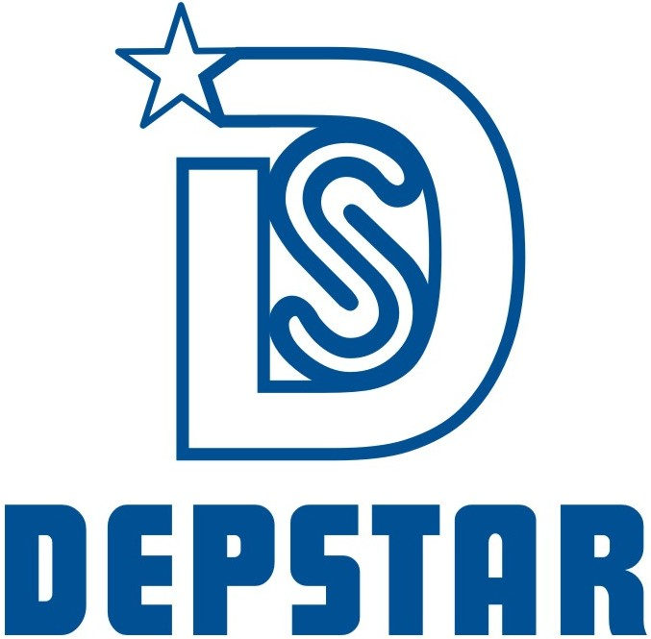

Week-8 Report

Student ID: 20DCE019 | Student Name: Yatharth Chauhan
From Date: 27/06/2022 | To Date: 1/07/2022
Semester: 5th | Internship ID:

Work done in last week (Attach supporting Documents):

Technology: UI-UX Design

Project Title: Nasa Industries Redesign Web UI

- 27/06/2022 (Monday)
Working on Profile Section of Nasa Industries Project.
Confidential Design that’s why I can’t attached image.
- 28/06/2022 (Tuesday)
Completed the next part of profile section.
Confidential Design that’s why I can’t attached image.
- 29/06/2022 (Wednesday)
Completed the next part of Technical Specification section.
Confidential Design that’s why I can’t attached image.

- 30/06/2022 (Thursday)
Completed the next part of Product Pop-Up section & Project Section.
Confidential Design that’s why I can’t attached image.
- 01/07/2022 (Friday)
Design New One Nasa Industries Eco-Friendly Logo.
Confidential Design that’s why I can’t attached image.

References:

https://nasaind.in/

Signature of External Guide Signature of Internal Guide

